**Assignment No. 01:**



**Spring 2025**

**CSE-303L Data Communication and Networks Lab**

# Submitted by: **Naveed Ahmad**

Registration No.: **22PWCSE2165**

Class Section: **B**

“On my honor, as a student at the University of Engineering and Technology, I have neither given nor received unauthorized assistance on this academic work.”

Student Signature: ______________

Submitted to:

# **Dr. Ihsan Ul Haq**

April 08, 2025

Department of Computer Systems Engineering

University of Engineering and Technology, Peshawar

Oodeded

**Task 01:OSI MODEL:**

* Which layer is responsible for end-to-end communication between running applications?

1. 4

* Top of Form
* Bottom of Form
* Which layer is responsible for routing packets to the proper network?

1. 3

* Top of Form
* Bottom of Form
* In the OSI model, which layer is responsible for encoding the application data?

1. 6

* Top of Form
* Bottom of Form
* Which layer is responsible for transferring data between hosts on the same network segmentTop of Form

1. 2

**TASK 02: TCP/IP MODEL:**

* To which layer does HTTP belong in the TCP/IP model?

1.Application layer

* Top of Form
* Bottom of Form
* How many layers of the OSI model does the application layer in the TCP/IP model cover?

1. 3

**TASK 04: IP ADDRESS AND SUBNETS:**

* Which of the following IP addresses is not a private IP address?

1. 9.69.147.197

* Which of the following IP addresses is not a valid IP address?

1. 192.168.305.19

Top of Form

**TASK 05:UDP AND TCP:**

* Which protocol requires a three-way handshake?

1. TCP

* What is the approximate number of port numbers (in thousands)?

1. 65

**TASK 06:ENCAPSULATION:**

* On a WiFi, within what will an IP packet be encapsulated?

1. Frame

* What do you call the UDP data unit that encapsulates the application data?

1. Datagram

* What do you call the data unit that encapsulates the application data sent over TCP?

1. Segment

**TASK 06:Telnet:**

* Use *telnet* to connect to the web server on. MACHINE_IP What is the name and version of the HTTP server?

1. **lighttpd/1.4.63**

* What flag did you get when you viewed the page?

1. THM{TELNET_MASTER} Top of Form

**Task 08: Conclusion:**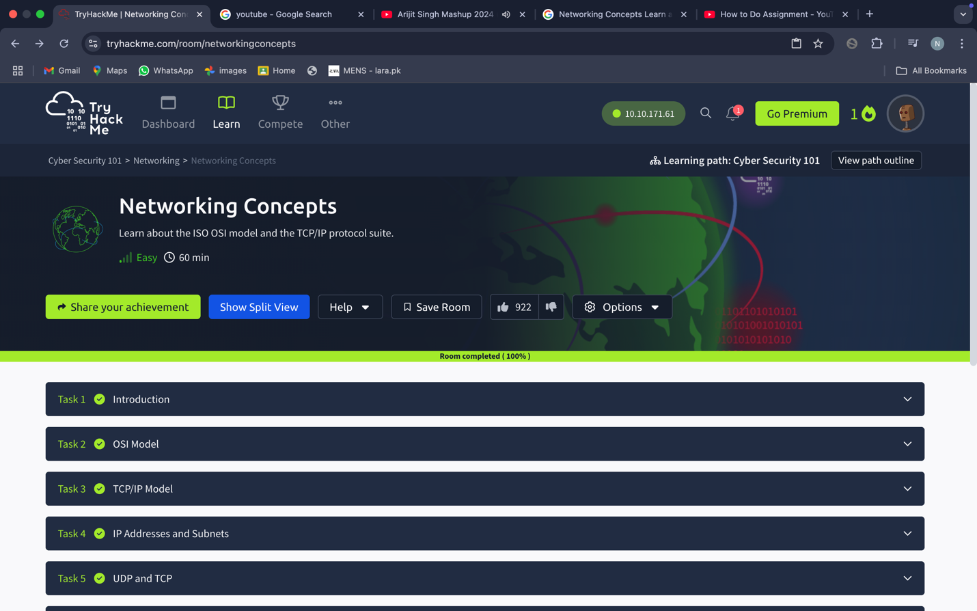

**Competed Rooms 01:**

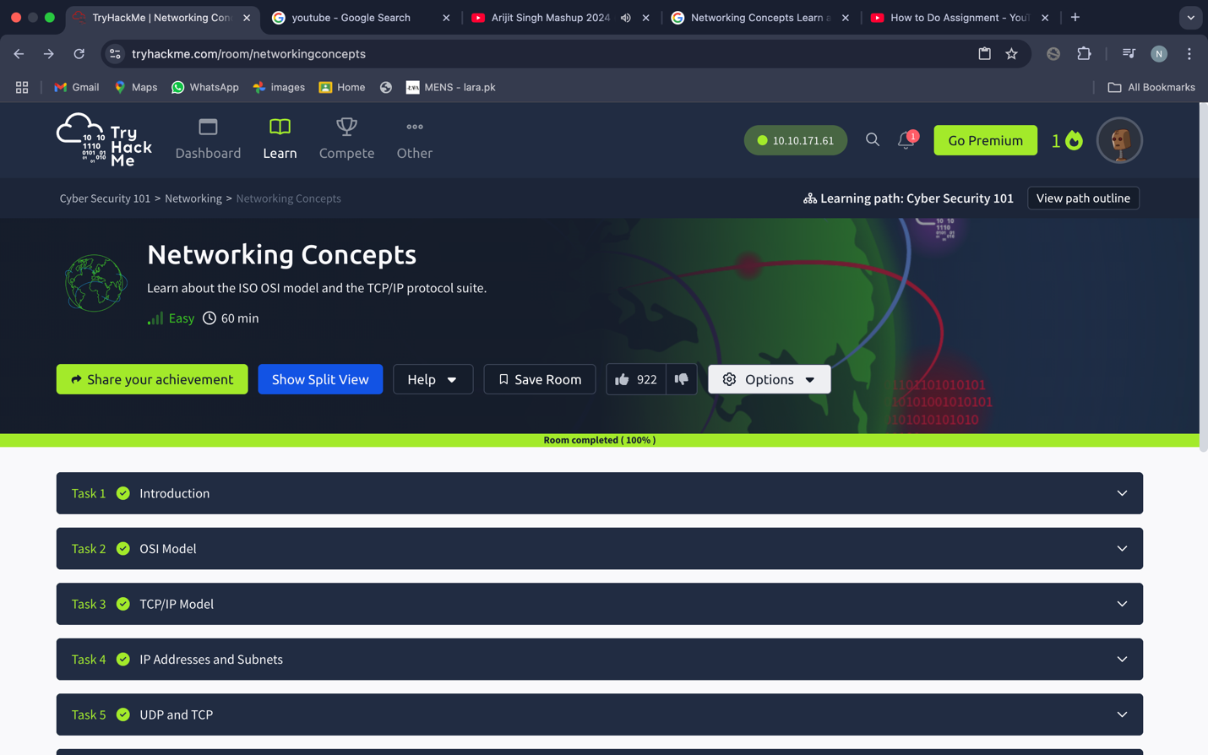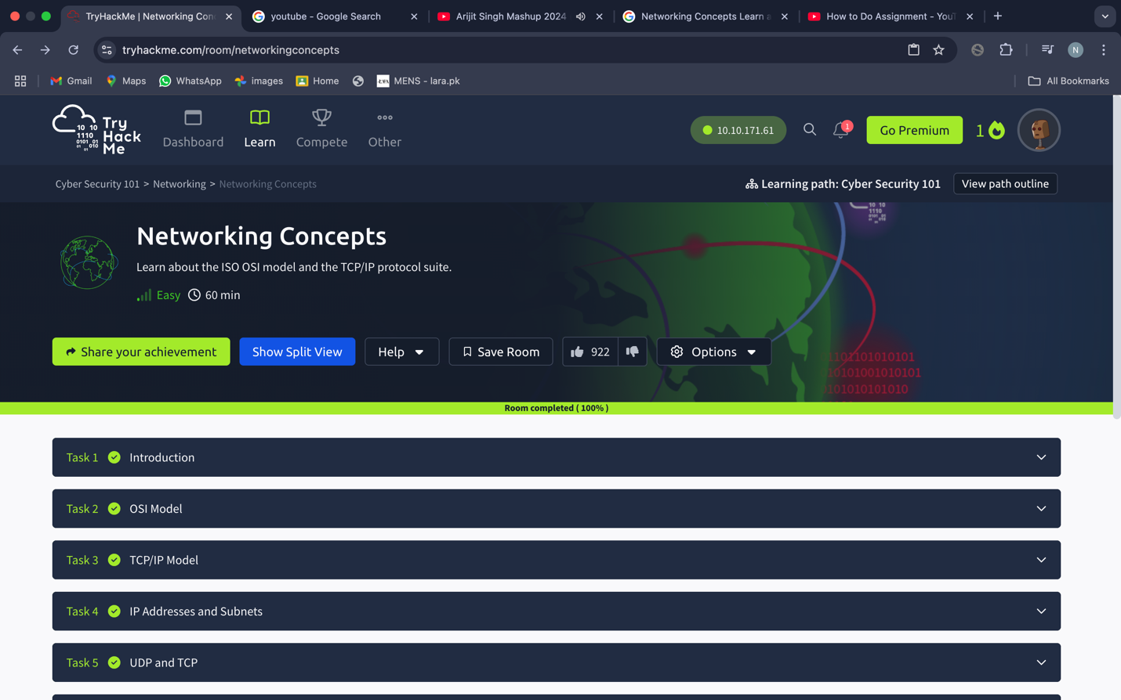Bottom of Form

Bottom of Form